Use the **Image_Create_Template.py** code, **shapeSugarLand1 CSV** file, and the **ADMIN1.jpg** file to pull the text from the ADMIN1.jpg file and deploy it to Plotly Dash.

Once the code is running, the text data from the invoice will be displayed under **Characteristics of shape,** for example, the image below**.**

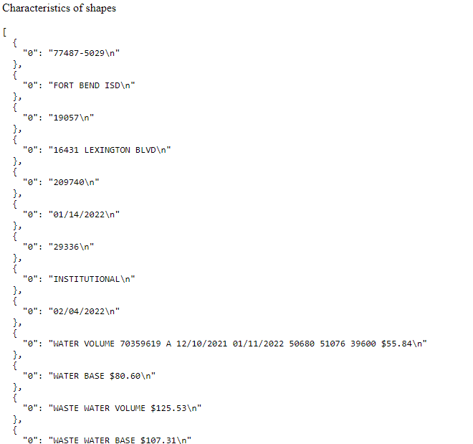

**Your Task:**

1. Format the text data in columns using Plotly-dash. Improve the way the text is visualized.
2. Make suggestions to the **Image_Create_Template.py** code and make changes in order to improve its functionality.

FYI: the purpose of this test is to get a better understanding of your problem-solving capabilities and creativity. The **Image_Create_Template.py** code shared in this test is a rough draft of the final version so feel free to reinvent/adjust (aim to impress) it as long as the end result is the automation of gathering the data from invoices and placing the text in columns using Plotly-dash.